Baron’s Extreme Bars Wiring Tips

I decided to augment the instruction for installing the wiring in Baron’s Extreme bars since although the instructions supplied are not bad, they’re not stellar either.

These “tips” are designed to supplement, not supplant, the instructions which come with the Baron Extreme Bars. If you do not know the difference in the meaning of these two words, you should stop right here and return the bars and better yet, sell your motorcycle.

This is NOT designed to re-write everything the Baron instruction manual tells you to do. These are just tips in doing what they say which will make the job ahead of you palatable. I worked on this over two days for about a total of 8 hours. If I had to do it again, I figure it’d take me about 3 hours with what I learned. Hopefully this will facilitate a smoother experience for you than mine.

First, I wouldn’t wish this upon anybody who is afraid of wiring harnesses. There are a LOT of wires that need to be removed and put back and they’ll only work right if you don’t make any mistakes.

I will only focus on what I feel they left out of the instructions.

First, get the following tools to make your job easier. I used these:

I bent the tip of the flat end screwdriver which helped me remove the brass connector tips from the plastic connectors. The broken one happened during the fight to get the connectors out—don’t get frustrated, get even.
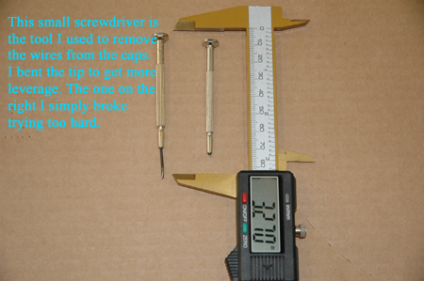

I labeled all of the wires—when several looked similar—I put a small piece of tape on them. These are no doubt interchangeable which is why they were the same color—but I didn’t want to take any chances. These are the black with gray stripe wires. You can go to my web site at http://www.morganhomes.com/VTX/index.htm to see the actual photos I took.

The inside of the bars where the risers are welded have a rough surface. If you get lucky, yours will not be as bad as mine. Peeking inside the bar it looked like a blocked artery, and of course, that was on the right side which has about twice as many wires as the left.

I would NEVER try pulling the wires with the bars mounted on the bike! I laid it all out on a piece of carpet on my garage floor.

Now before you start pulling wires, try your bars on the bike to make sure they fit on the bike—mine didn’t. The risers were just a tiny bit too close together at the base and when I tired to put the bolts in from underneath I couldn’t catch the thread. I’ve read about others having this problem. In a perfect world I suppose they’d line up exactly but these bars are hand made and all-in-all they do a pretty good job of lining everything up but there’s no room for slop when the bolts are in the trees so if the risers aren’t perfect you’ll be fighting with them with wires flinging around—do this first and save yourself some hassle.

I had to drill the holes in my triple tree a little larger so the bolts had some room to be maneuvered around and get the threads going. Once I got everything connected and running I took the bike down the road and the bars were off just a tad cocked to the left. Having a little slop now in the hole I was able to move the bars and tighten them straight. This required a shim under each riser. I made this shim out of a flat washer which I cut in half. I put one half under one riser in the front and the other half under the opposite riser in the back. When I tightened it all down that moved the bars just enough to realign them perfectly. Now they’re straight.

Pulling the wires:

I started with the LEFT side, although the instructions said start with the RIGHT since it would be easier (less wires)—whatever. I believe that if you can get the wires through the LEFT side the RIGHT side is more manageable and I’d hate to be tugging away on the LEFT side as hard as I did with the RIGHT wires flopping around annoying me. I say, start with the LEFT side.

I went to a bike shop and got a broken bicycle cable like this; with the little knob on the end which really helped (as you will read later).
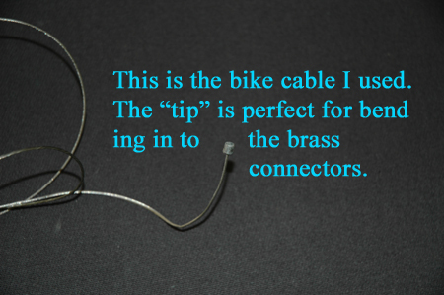

I used one of these tools to fish for the cable. Note how I bent the tines (claws) backwards from their original position to make it easier to “Hook” the bike cable. Of course I tried for about a half hour before I figured that out.
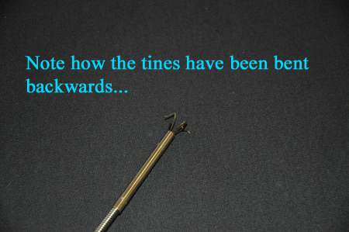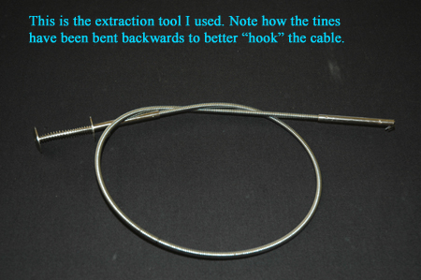

Before you proceed, practice using the extractor tool to see how little you need depress the handle before the claws start to open. Remember—there are burrs from the weld in there and if you open the claws to much you’ll just catch on the weld, not the cable.

Feed your “fish” cable in from the side opening at the bottom of the riser first (not through the threaded end where your bolt will go), then feed the extraction tool in from the end of the handle bar. Open it slightly to hook the bike cable and pull it back out just to where you can see the end of the cable in the handle bar hole—not the end of the bar—the hole where the wires will exit, Fish it through and then you’re ready to start feeding the wires back.

Tips for feeding the wires.

Make sure you remove all of the old wrapping from the wires. You’ll notice that the large green ground wire needs not be included. Once you remove this green wire from the BLUE cap you can leave it connected to the headlight connector.

You’ll make your life unbelievably easier if you cut off the other headlight connectors since they are really too large to get easily through the handle bars anyway. Be sure to cut them back far enough so you can easily solder them later and have enough wire to work with—give yourself about three inches. These two large wires (the large Blue and White wire) I lengthened later so cutting them was the best thing I could have done. Of course I tried for about two hours to get them through with the brass “L” shaped connectors before I gave up and cut them off. Save yourself a LOT of headache and cut them right away. I am confident that with burrs I had in my bars it was impossible to get them through had I not cut these two ends off. Remember, the green ground wire you can leave alone—it will NOT be pulled though the bars.

There are several brass connectors which are for the turn signals which have a plastic sleeve around them. I cut the plastic outside insulator off of those too. Later when reconnecting them, I simply used black electrical tape around them for insulation in the headlight cowl. Those are your solid pale blue, pale blue with white stripe, orange and orange with white stripe. I opened up one of those connectors with a pair of pliers and put the bike bicycle cable with the tip on it nesting in the connector tip and closed it back up tight with the pliers. That way when you PULL hard on the wires you won’t pull your cable out of the taped wires you’re feeding through the bars. Of course that little tip took me about three times before I figured that one out. Now that you have your first wire hooked to the fished bike cable, you’re ready to start staggering and tapping. Never put two connectors side by side start the next one BEHIND the last one and so on until all wires have been staggered and wrapped with black tape. Do this ALL THE WAY up to the switch box so that when you’re done it’s already wrapped. Also, by doing this your wires INSIDE the bars will still be wrapped and have less likelihood of the burrs inside the bars rubbing off the insulation of the wires.

Like they say in the instructions, grease the taped wires well AND PUSH DO NOT PULL UNTIL YOU HAVE PUSHED the wires as far as you can push. This will keep them from bunching up inside the bars. Then pull some and when you feel resistance, start pushing again, then pull again.

Once the wires come out the side of the riser pull them as far as you can and start unwrapping only until you get to the last brass connector end you wrapped., then STOP unwrapping the wires—leave them wrapped and it will save you some work later.

Reconnecting the wires into their respective plastic connector is literally a snap IF you have good digital photos AND a good system for keeping track of what wire goes where. You can download the photos I took if you find yourself in trouble, or look at my wiring notes I took. Although simply using mine would make for a much faster job, I recommend you do it yourself so it’s fresh in your memory. Alas if you screw something up use mine as a fall back.

Remember when putting the bars back on the bike to slide the throttle sleeve on the right side before bolting them on as it’s a VERY tight fit to get it on once the bars are installed. I did it, but it was REALLY close to not reaching. Do I even need to mention having a pillow over your tank in case it all falls down?

BTW--the only wires I had to lengthen where the two headlight wires—the green ground of course I left alone. But since I had cut the connector tips off anyway, it’s was a simple soldering job. I then used tape and shrink wrap for all of my connections.

Good Luck and God’s speed.

Cheers,

Wyatt

